Navigate to Networking and Content Delivery -> Route 53

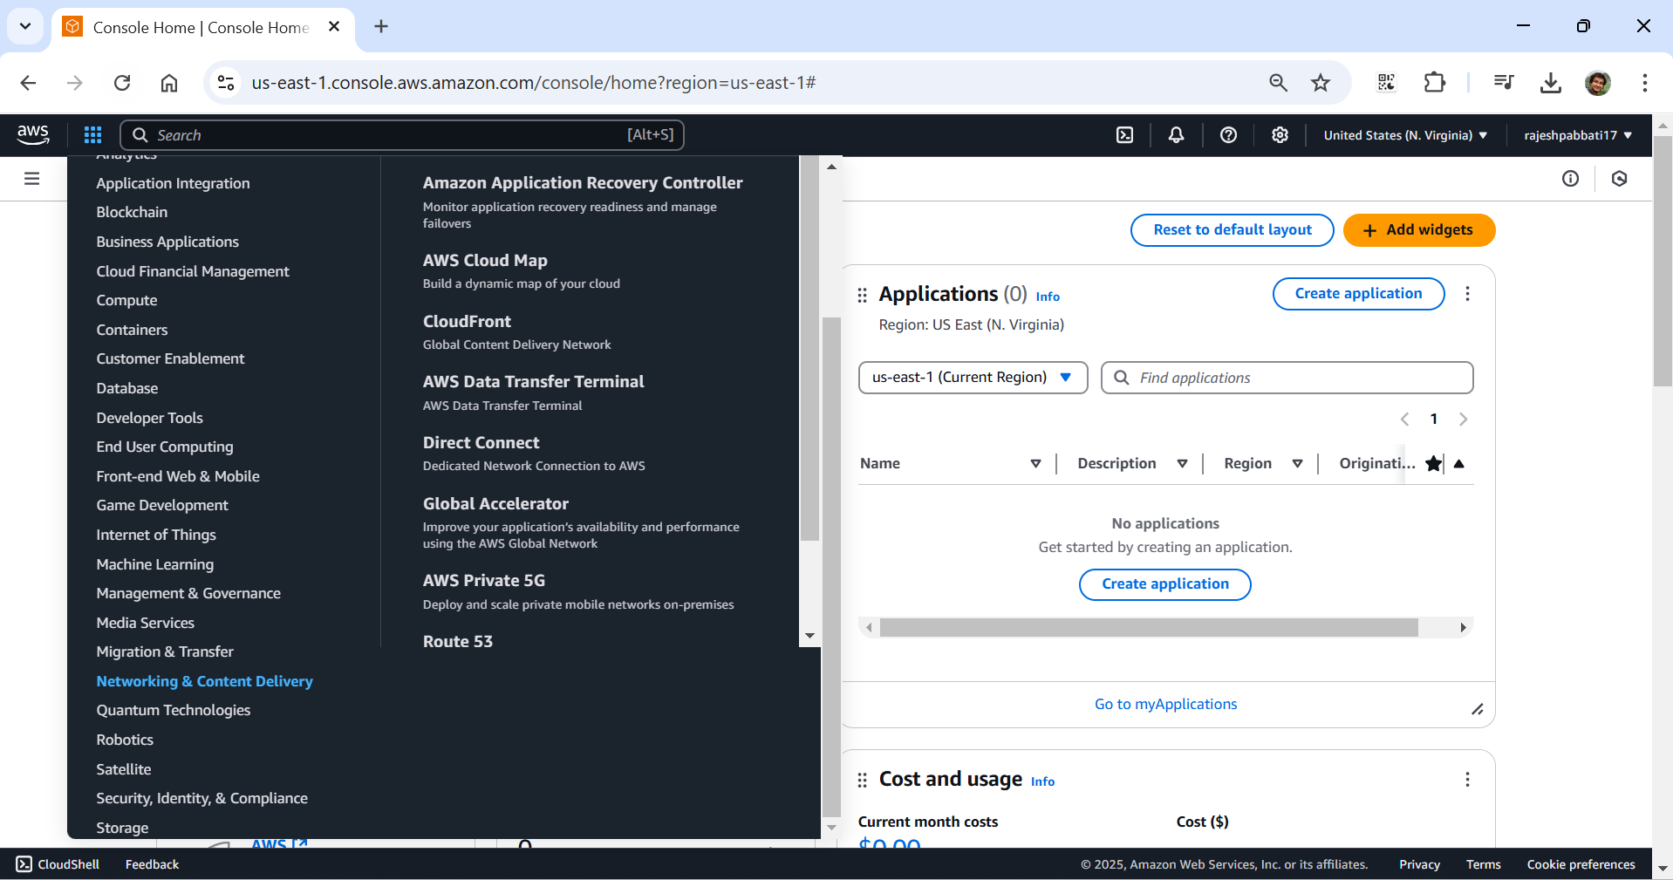

Click on Get Started

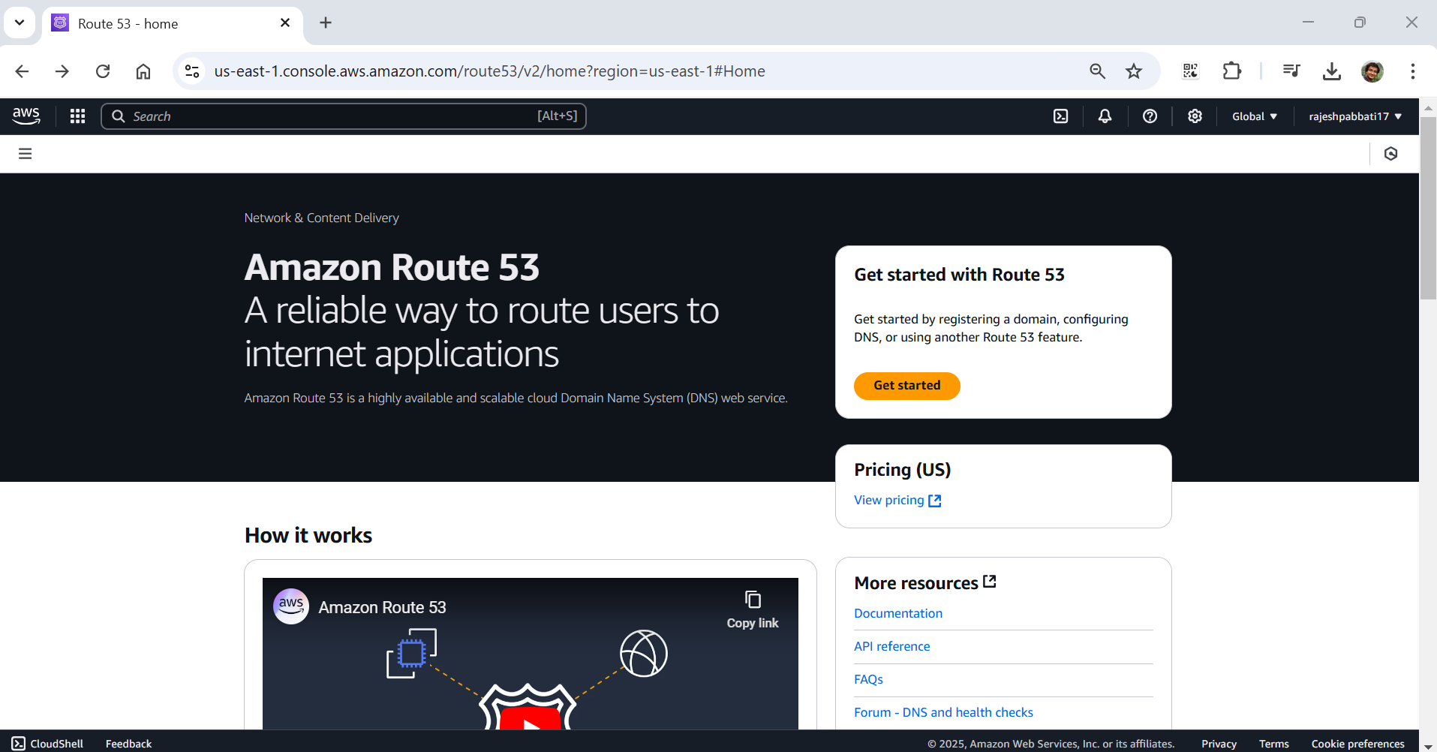

Select Create hosted zones and click on Get started

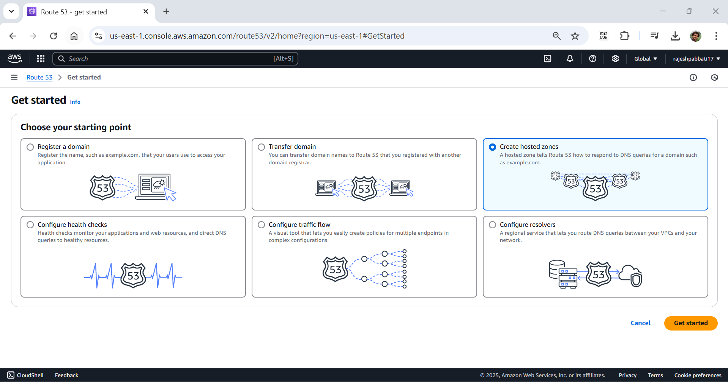

Give domain name and description and click on create hosted zones. NS and SOA record will be created

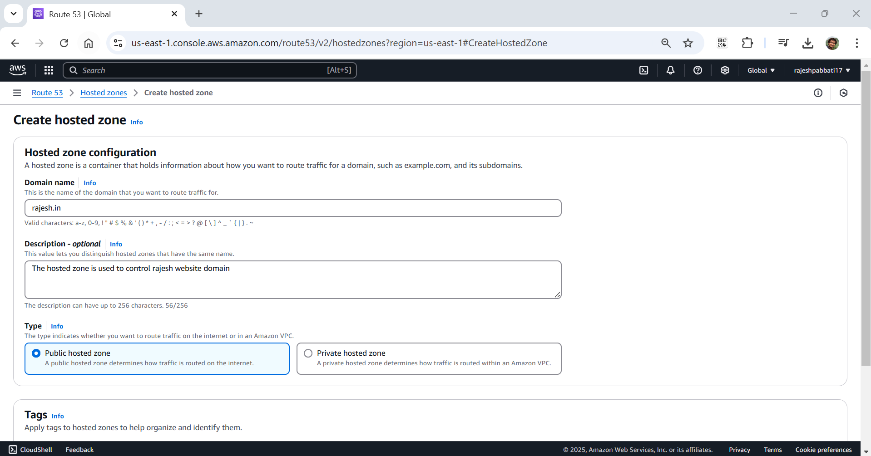

Navigate to Compute -> EC2

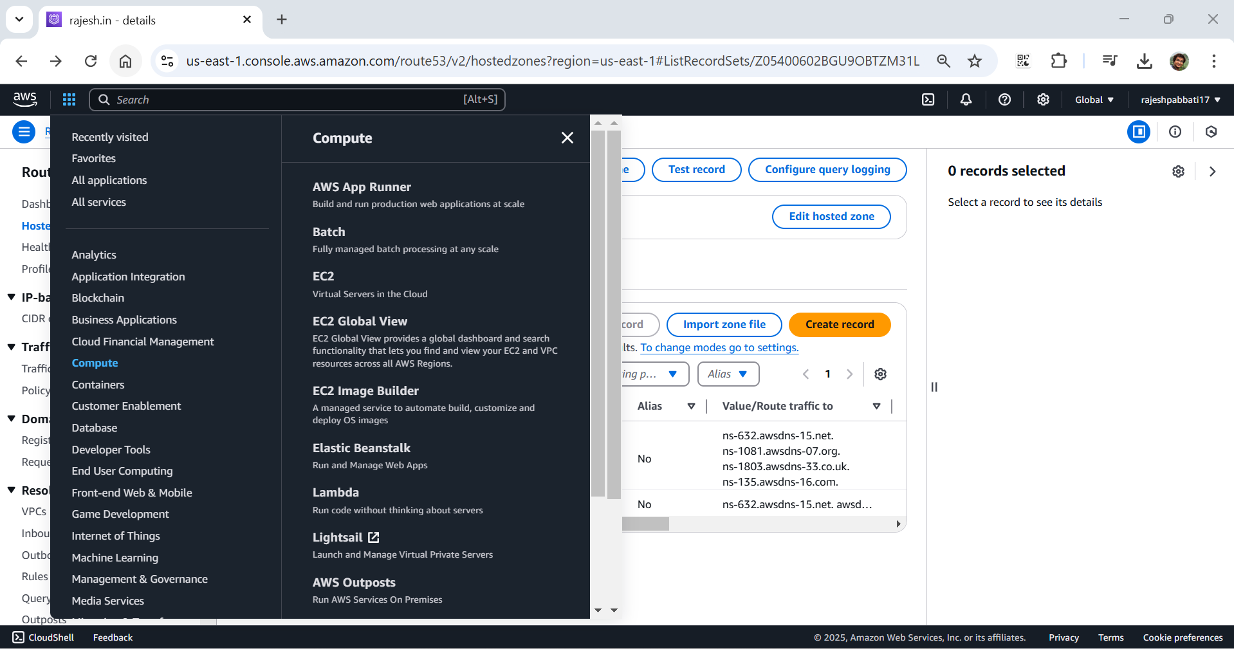

Click on instances

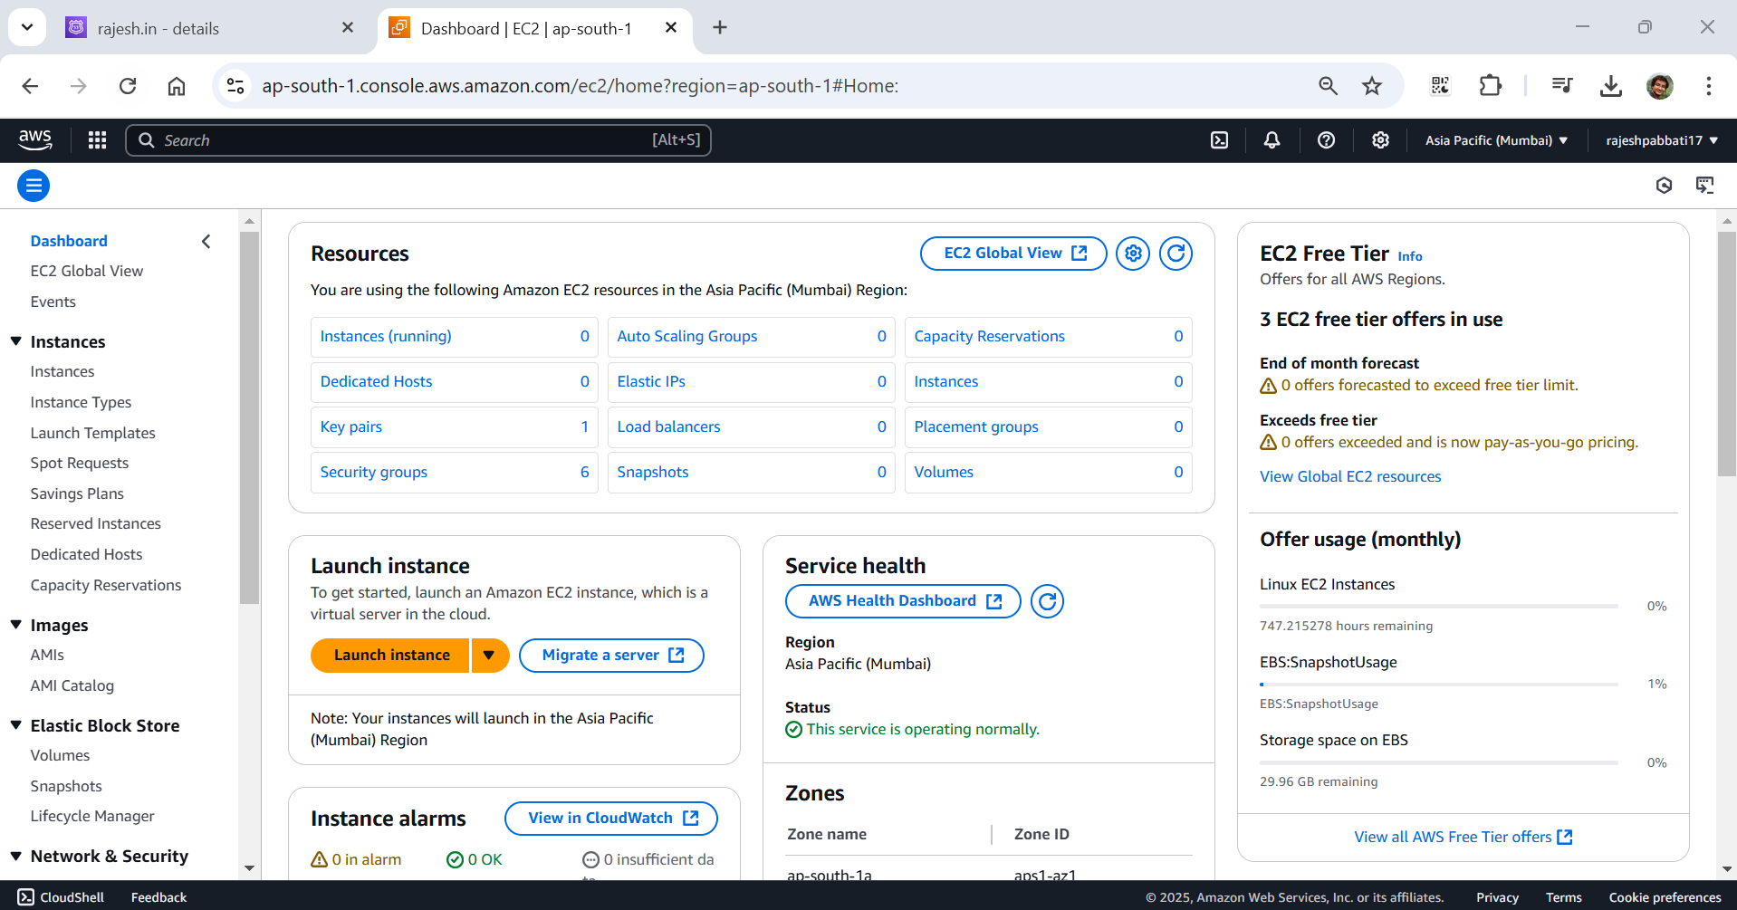

Click on launch instances

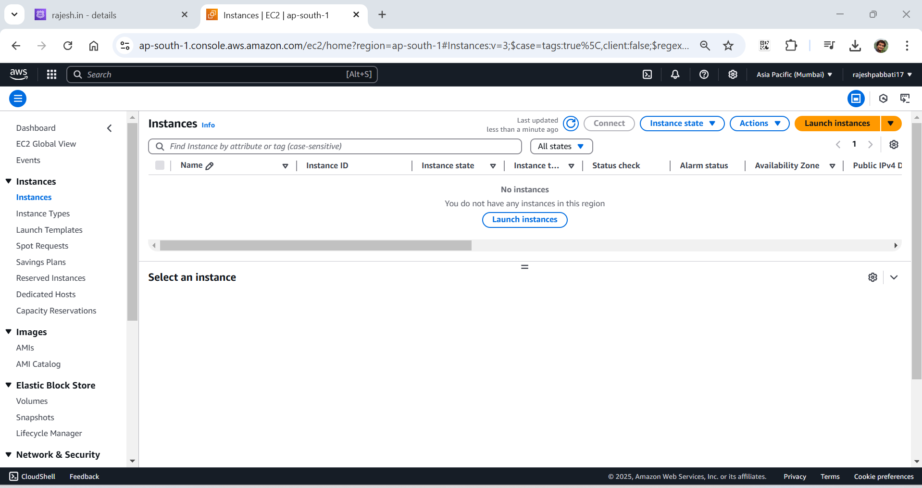

Give name

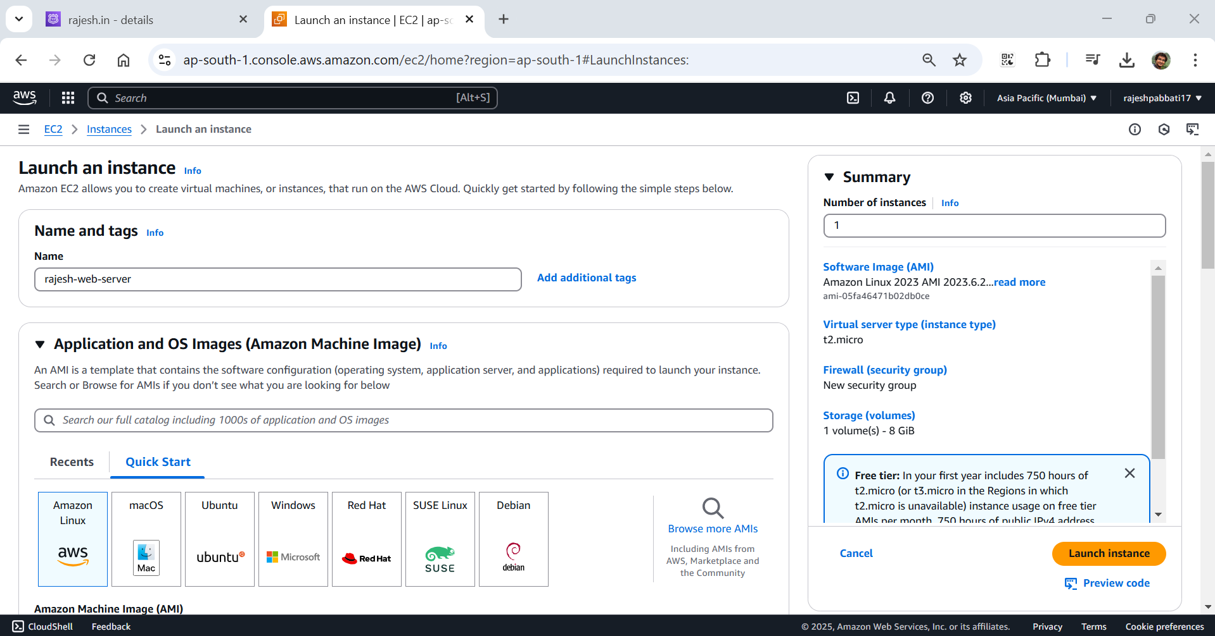

Select key pair, select security group Linus-SG and click on launch instances

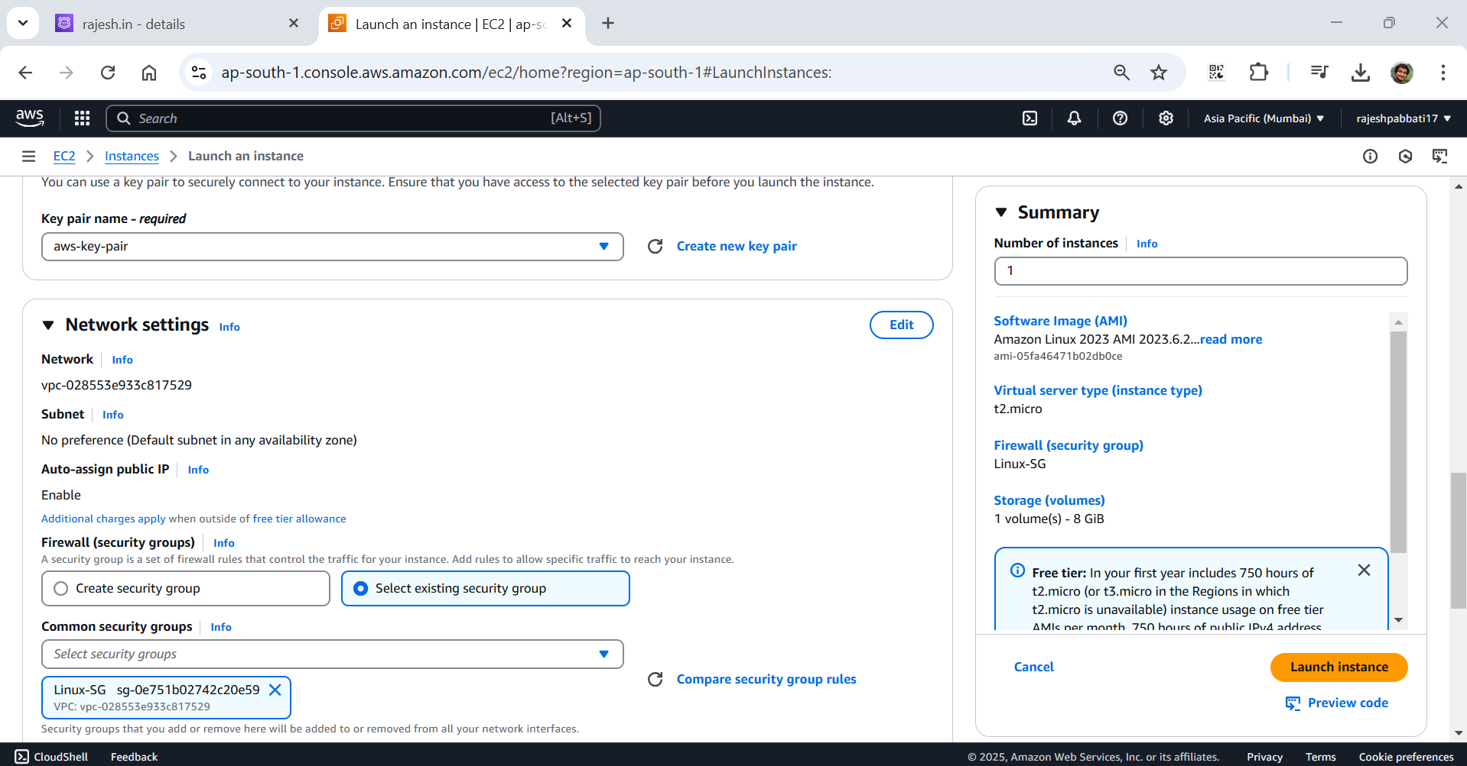

Select instance and click on connect

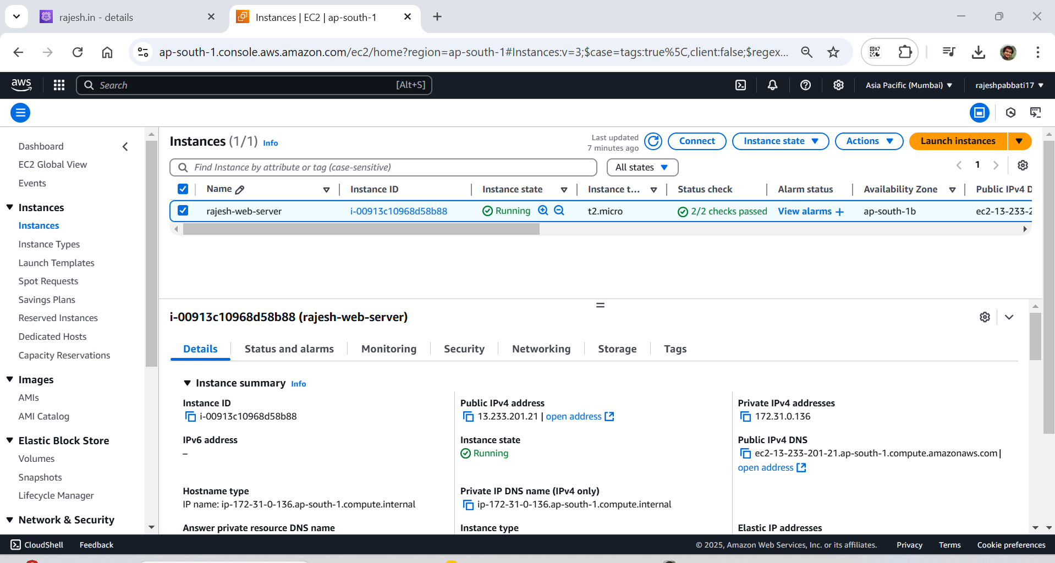

Click on connect

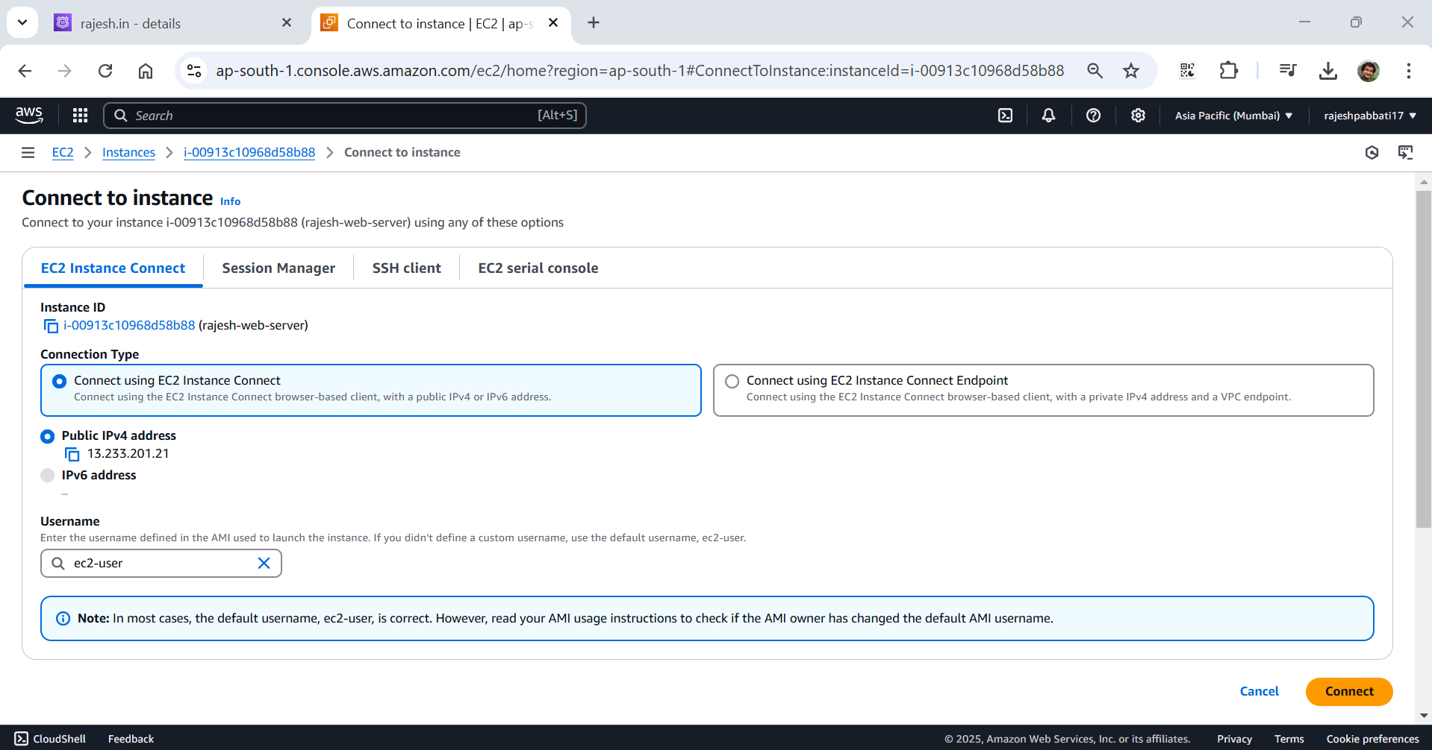

Enter one by one

Sudo su, update yum and install

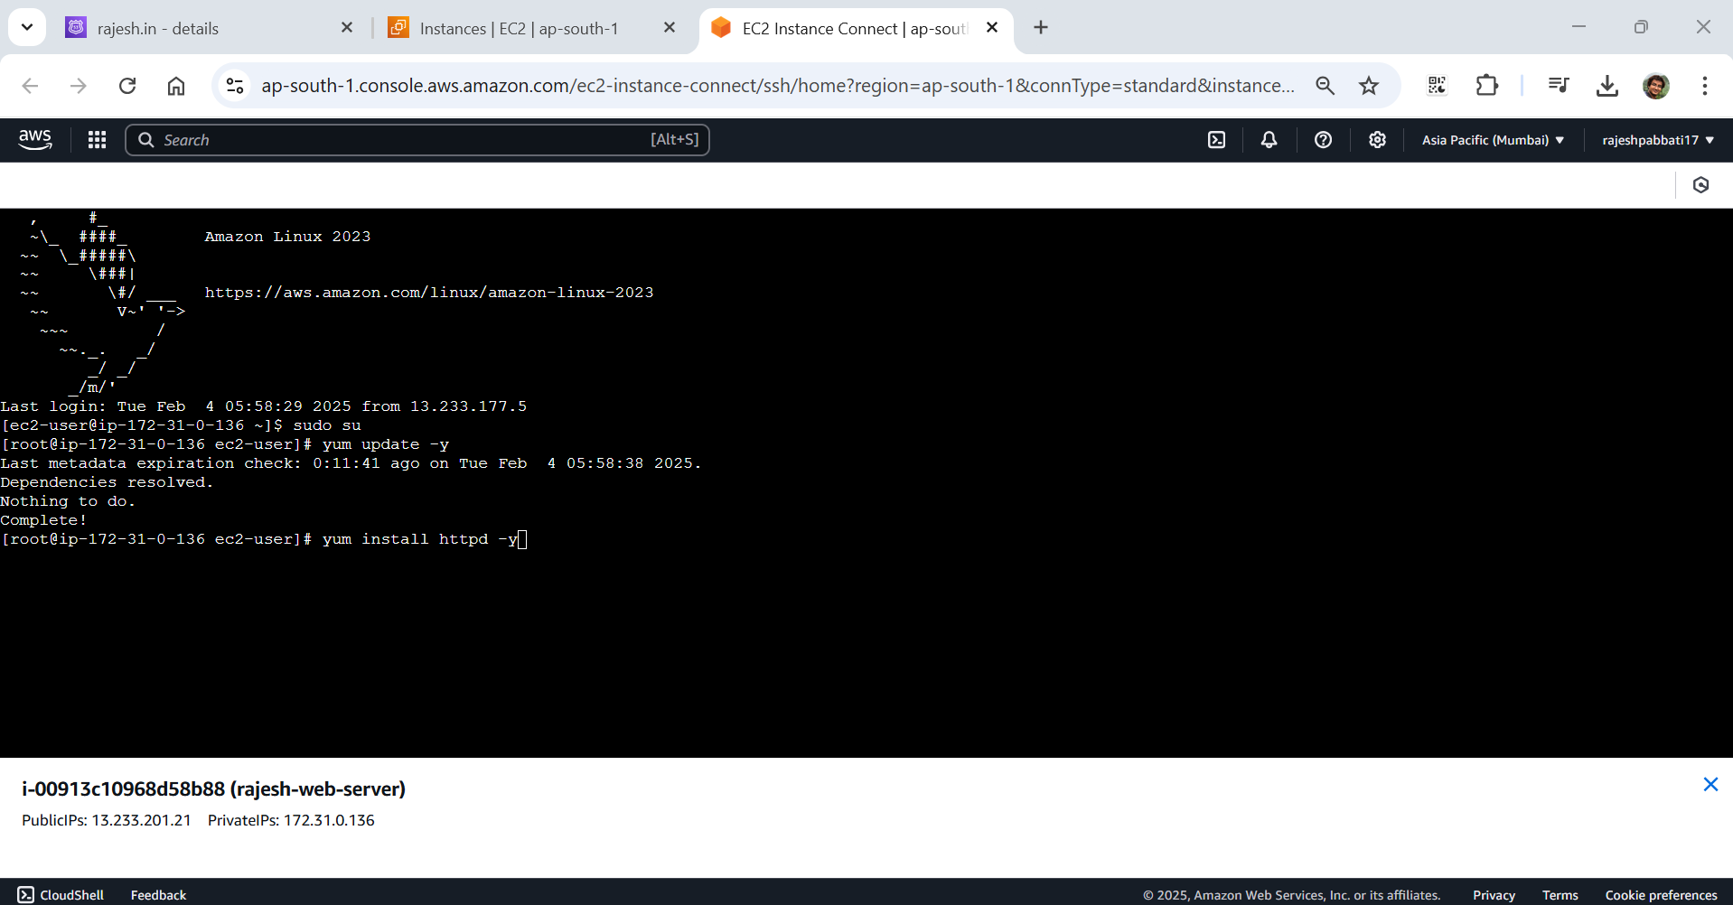

Start apache service, check service started and change directory to /var/www/html

Open index.html in vi editor

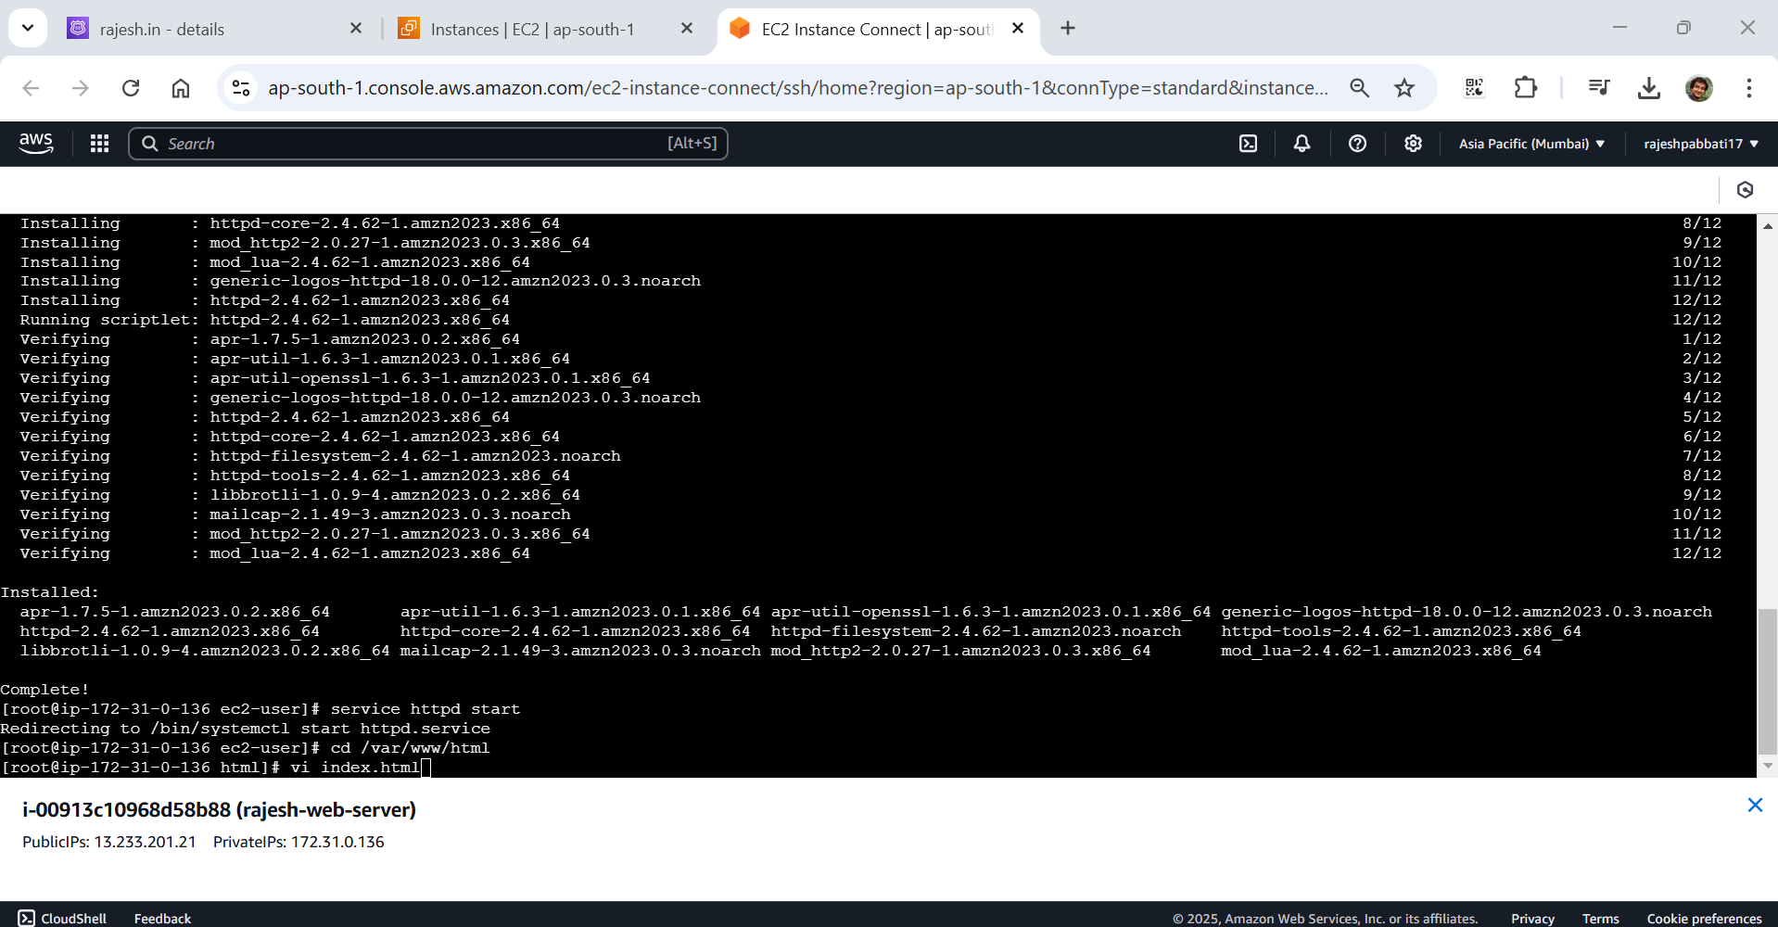

enter “i” changes to insert mode enter the text rajesh.in and click esc button followed by :wq! And click enter

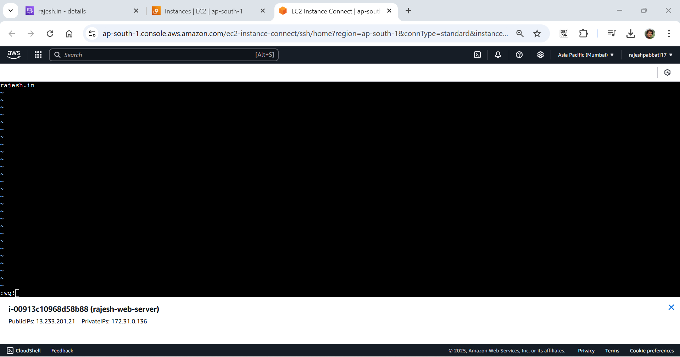

Copy the public ip of instance

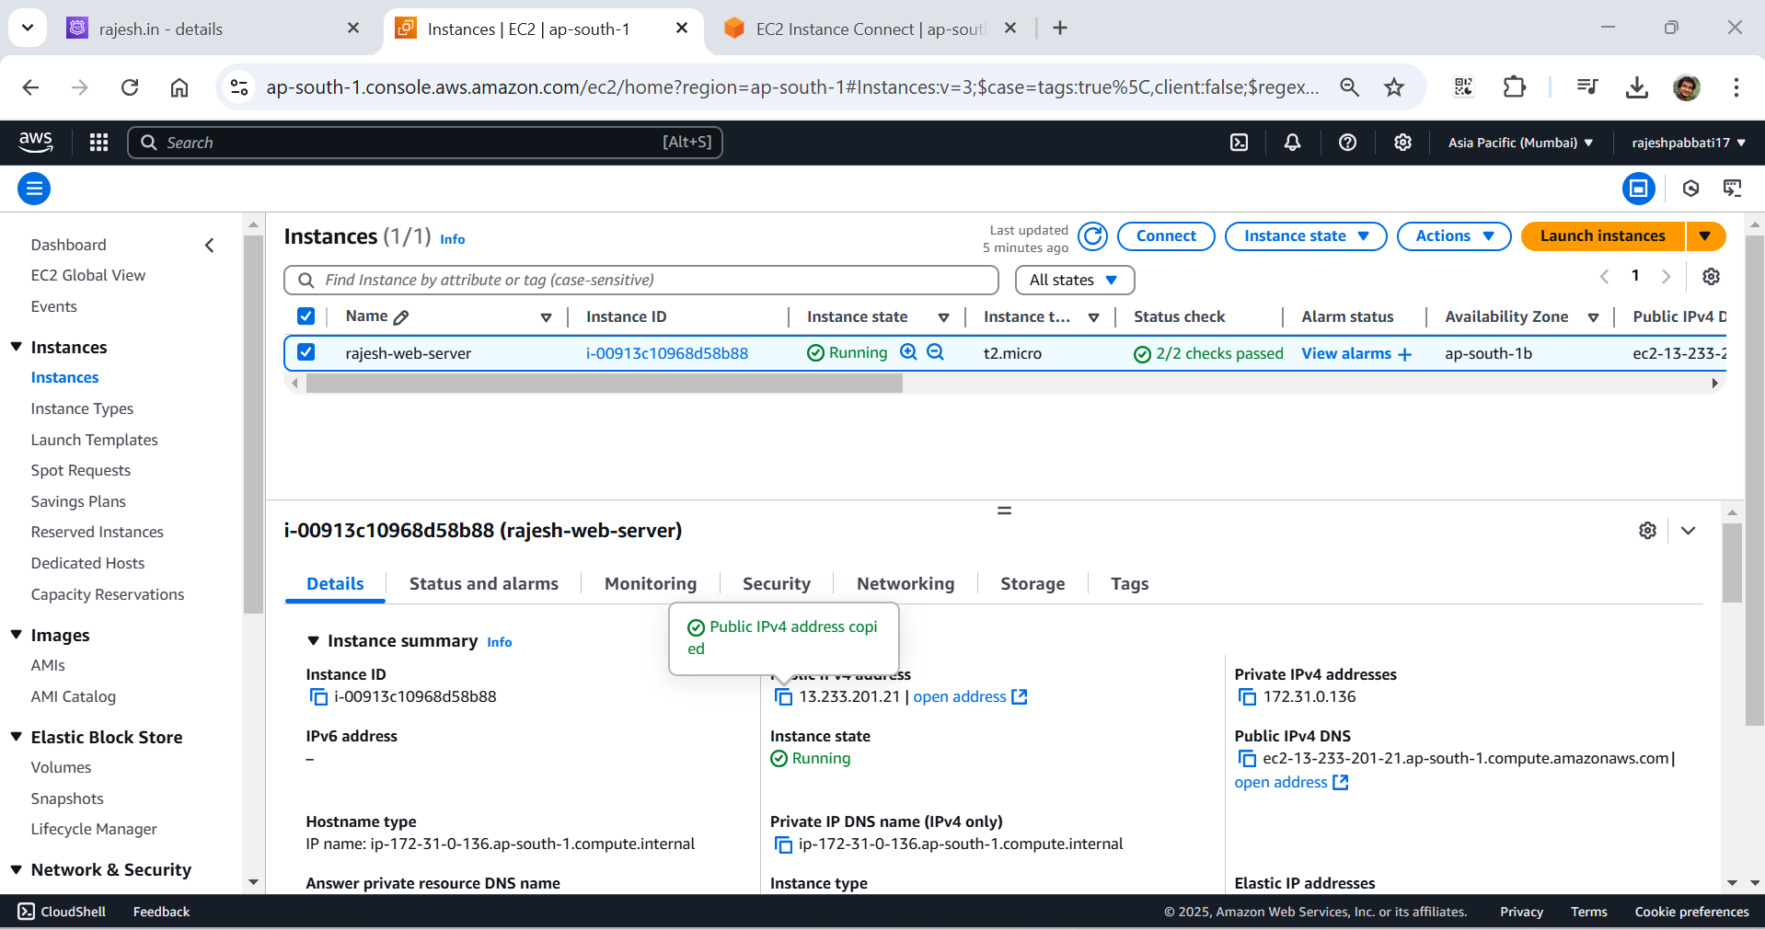

Open new tab and enter “http:// <copied public ip>” and hit enter rajesh.in will display

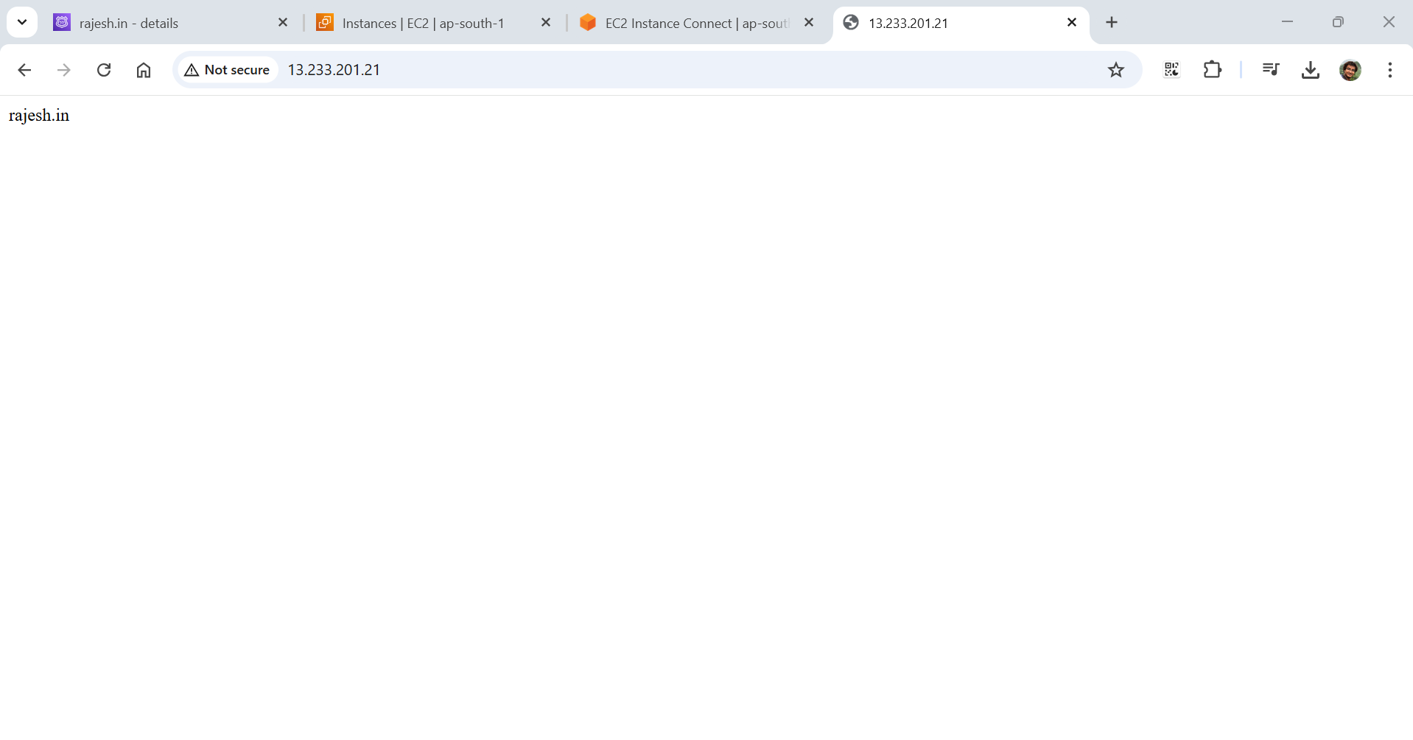

From Route 53 click on Create record

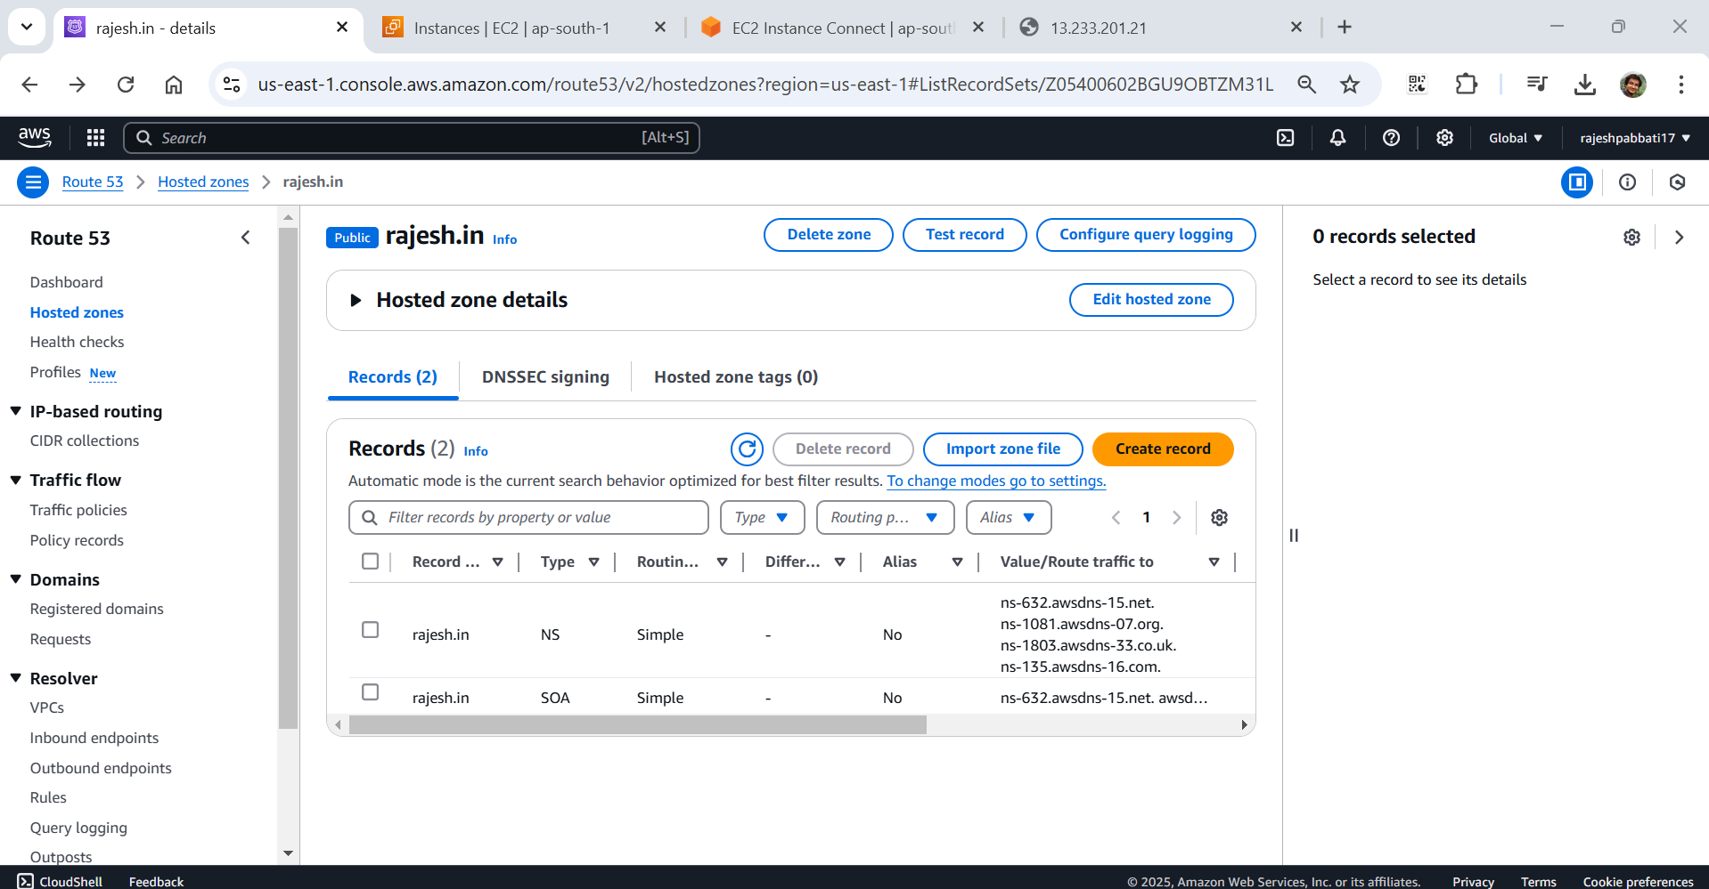

Select Record type “A” and enter the public ip of instance in Value and click on create record.

This will map the rajesh.in with ip.

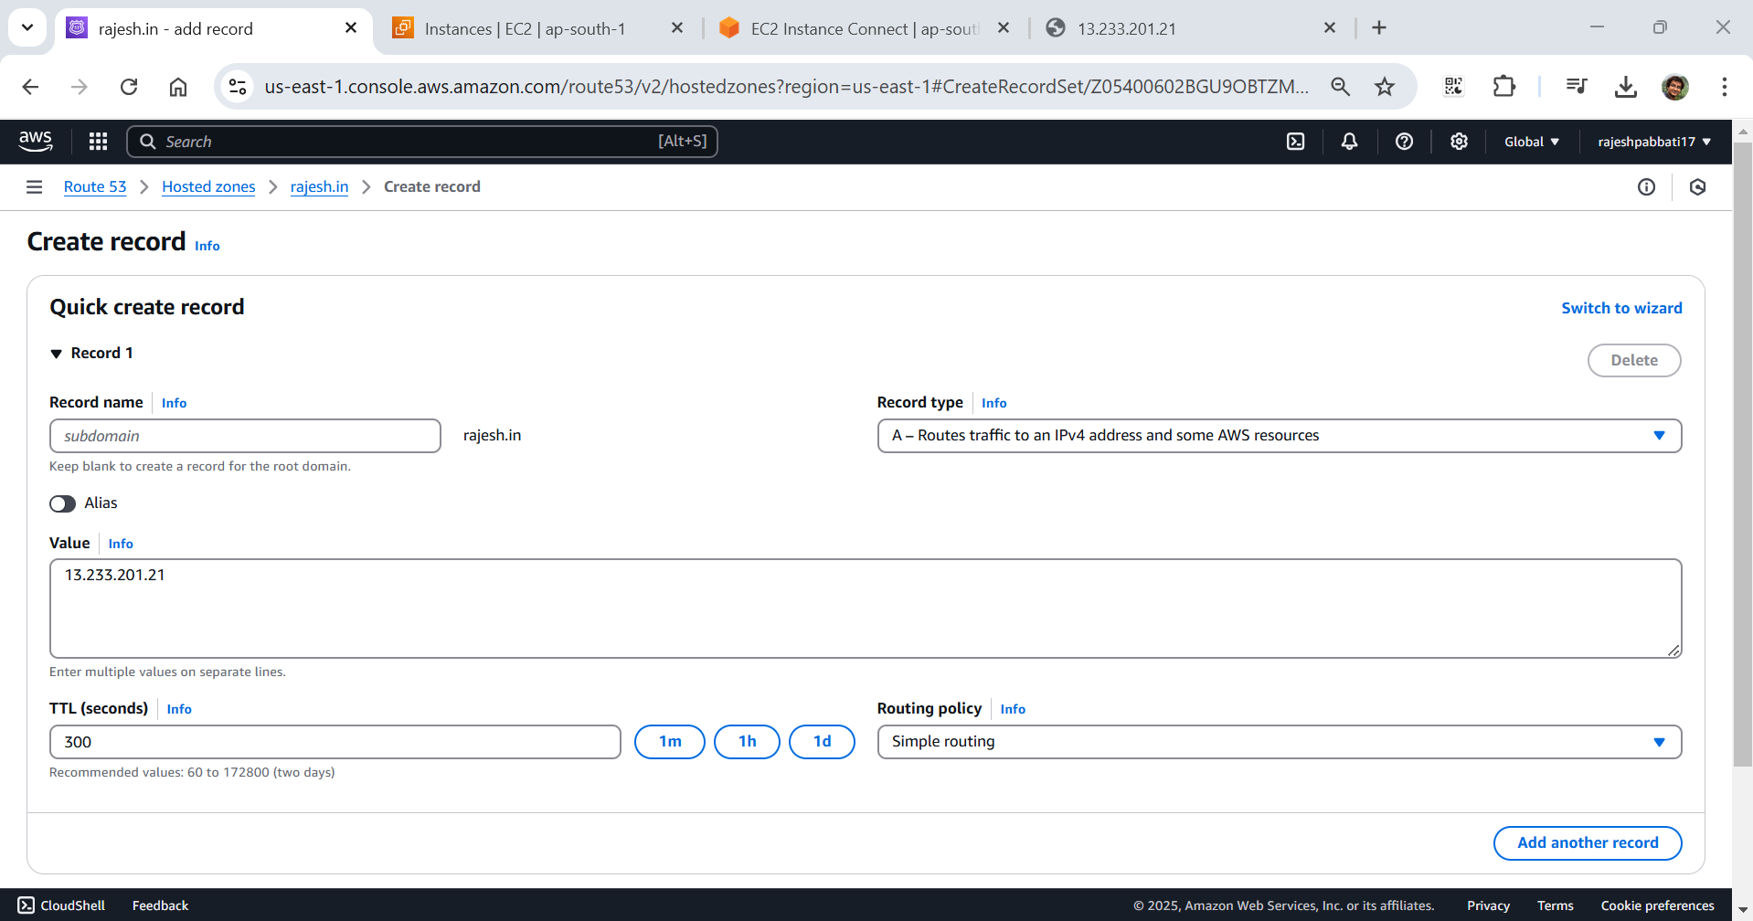

A record will be created. Again click on Create record

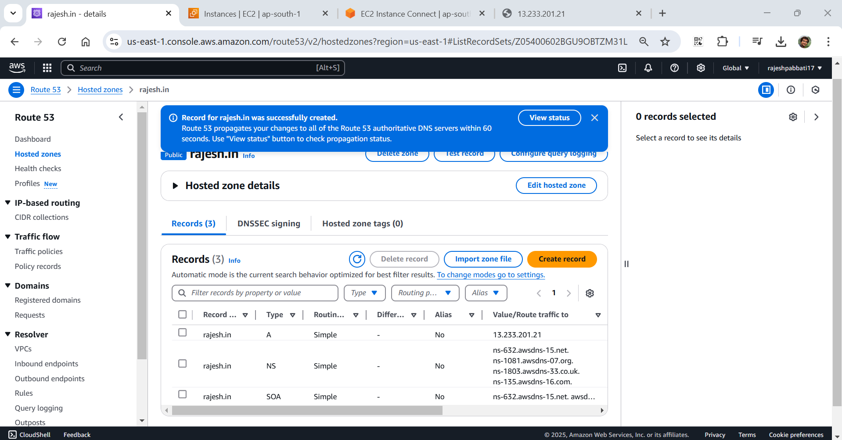

Enter the learning in record name, select Record type CNAME and value as rajesh.in.

With this if I enter learning.rajesh.in will redirect to rajesh.in. Click on Create record

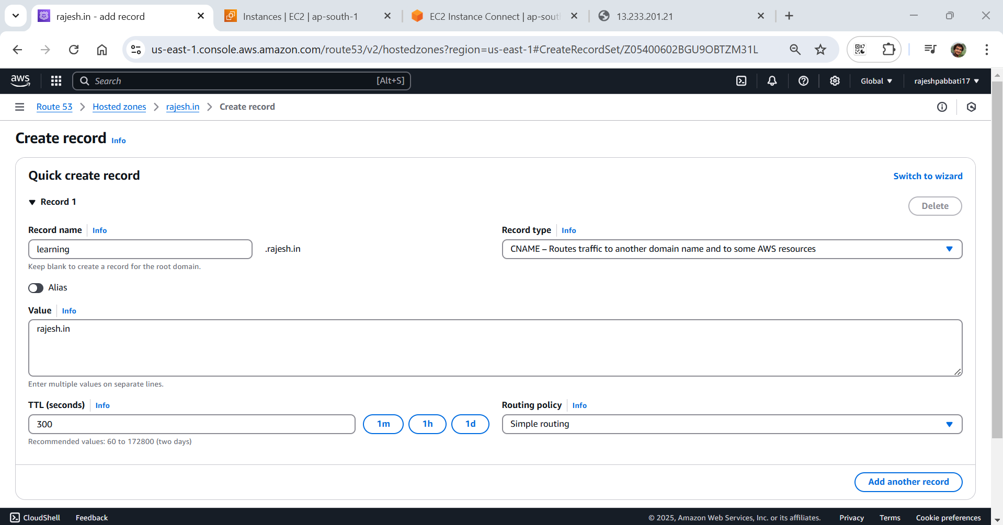

CNAME record also created. Buy rajesh.in domain name from AWS or godaddy.com or bigrock.in. In that map NS record “Value/Rout traffic to” copy these four values and paste in the rajesh.in where it purchased.

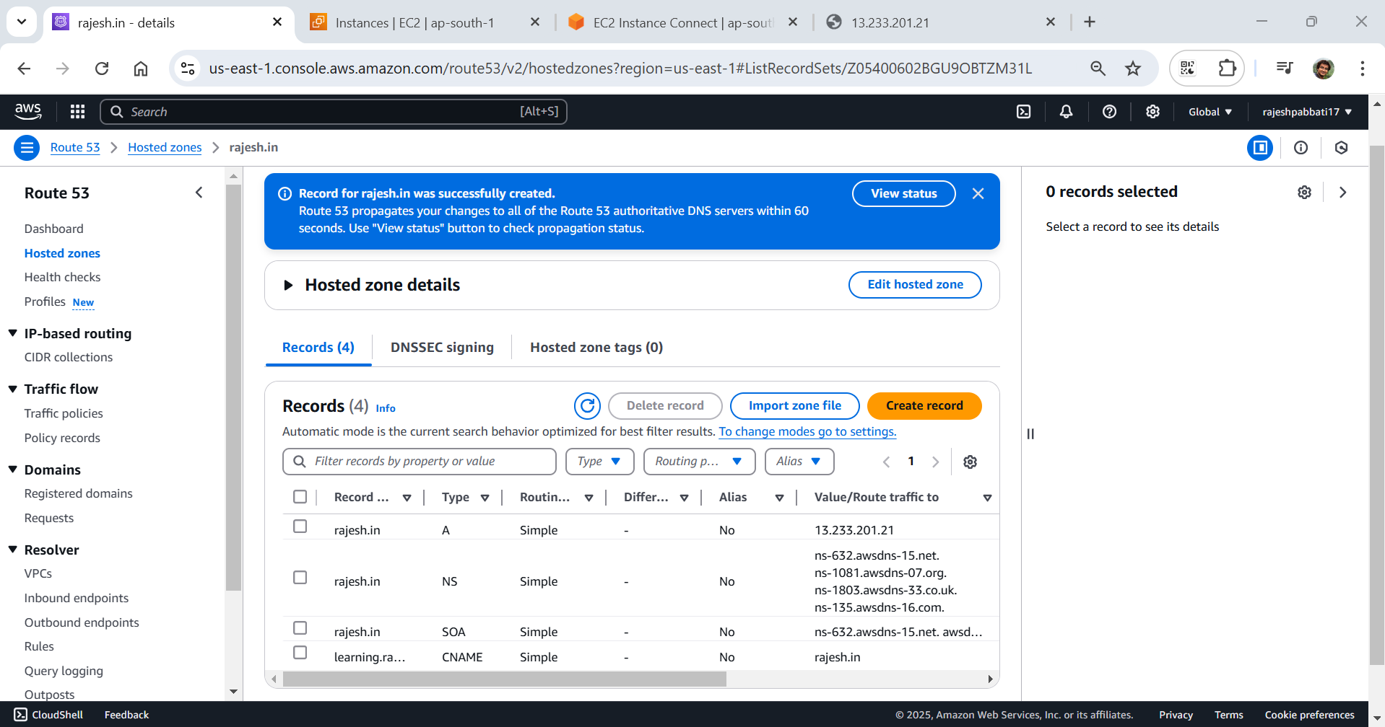

Enter nslookup rajesh.in in the instance if the ip came it is connected else for sometime to map ip with domain name rajesh.in

